FDN04: Zowe v3 Migration Troubleshooting
Participant handout.
Lab environment: Zowe 3.5 on z/OS, delivered on the Strong Network platform.

Part 1: Workshop Setup and Reference Materials
The whole workshop runs in your browser on the Strong Network platform.
Zowe Explorer, the Zowe CLI and the connection to the mainframe are already installed and configured, so there is nothing to install.

You will work in three places:
Where | Use it to
IDE | Zowe Explorer to browse jobs and job output, edit files on z/OS, issue MVS commands  Readme with your credentials and mainframe details  Copy of this reference materials for copying commands and directories
SSH | Run commands on z/OS: zwe, java, netstat, cp
WEB | z/OSMF (Security Configuration Assistant, Certificate Setup Assistant for Z) and the API Mediation Layer pages
Actions that happen in one of these places start with a tag: IDE SSH WEB

Setup 1: Log in to the platform
- Open https://sn.ws.broadcom.com/ in your browser.
- Log in with credentials provided to you (mfwsuser<ID>@demo.broadcom.com)
- Wait until your workspace is ready, make sure you have correct project selected:

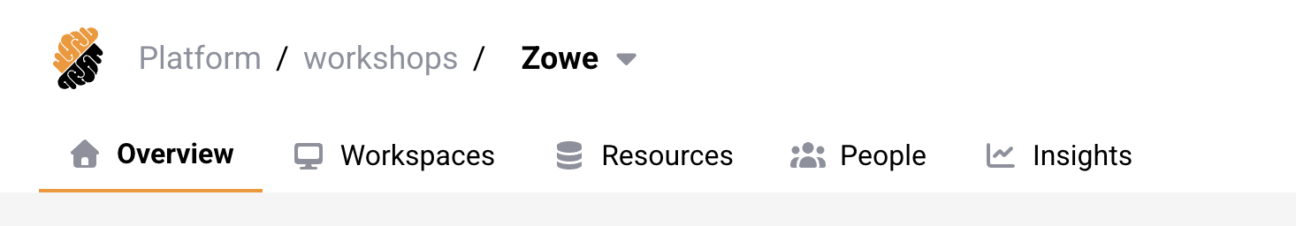
Platform overview:

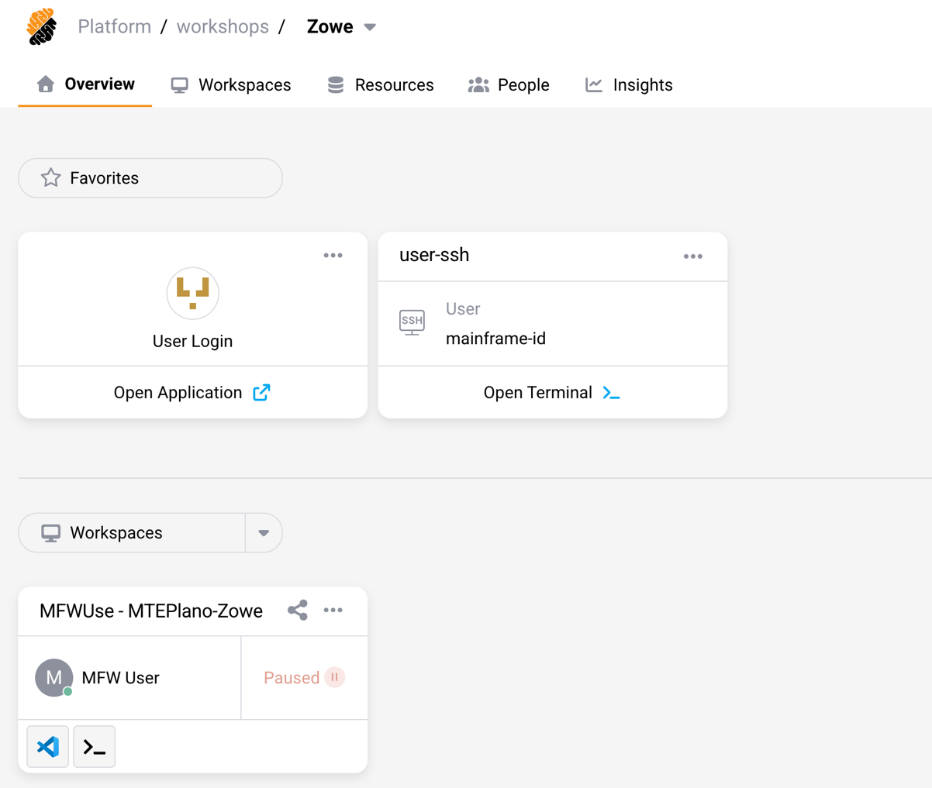
IDE

WEB

SSH

Setup 2: Find your personal details
Your user ID, password and any other value that is unique to you are not in this handout. They are in a README file in your IDE and on the printed card.
- IDE Open the IDE tile.
- IDE Open the README file
- Keep it open. You will need these details throughout the workshop.
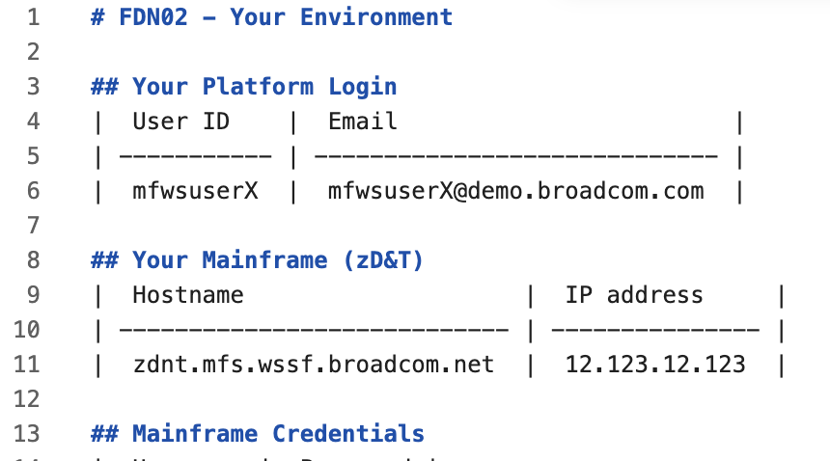

Setup 3: Check your tools
- IDE In the JOBS section of Zowe Explorer, click the Magnifying Glass (Search Jobs) icon.
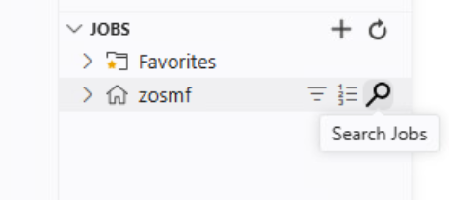
Click Create job search filter.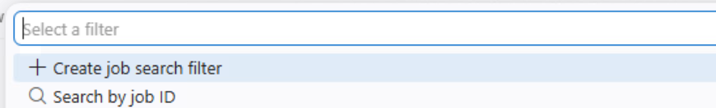
Set Job Owner to * and Job Prefix to ZWE*, then click Submit this query.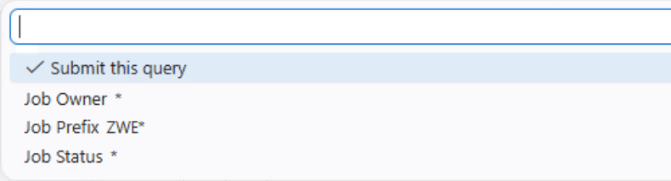
You should see the Zowe started task ZWESLSTC in the list.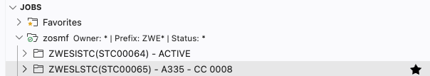

- SSH Open the SSH Terminal tile, it should automatically log you in. Run:
whoami
It prints your user ID.

- WEB Open the z/OSMF tile and log in with the same user ID. You should see the z/OSMF welcome page.

Checkpoint: You see ZWESLSTC in Zowe Explorer, whoami prints your user ID, and you are logged in to z/OSMF. If any of these fails, tell the facilitator now.

Part 2: The Zowe v3 Migration Troubleshooting Workshop
Scenario: your organization has just upgraded Zowe from v2 to v3, and the first start failed. The colleague who maintained Zowe is not available, so you are now responsible for bringing the API Mediation Layer online.
Rules of the exercise:
- You may restart the Zowe started task once, in Step 6. Until then Zowe stays down.
- You find and fix the problems with logs, documentation and validation tools instead of restarting and guessing.
- A real migration rarely goes wrong in five places at once. This lab combines them on purpose so you can practice the whole checklist in one session.
Documentation: https://docs.zowe.org/

Step 0: Initial Diagnostic
Your first instinct is to read the logs.
- IDE In Zowe Explorer, open the JOBS list and find the most recent ZWESLSTC job.
- Check its return code. The task ended with return code 8. 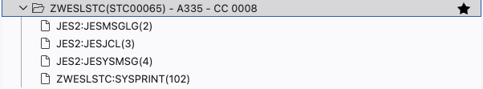
- IDE Expand the job, open its spool files and read the error messages

- Write down the first error messages you find:
Error messages

- WEB Open the Zowe documentation and find the Zowe v3 migration guide. Keep it open: Steps 1 and 2 follow its sections on system requirements and configuration changes.

Note: The log shows where startup failed, not necessarily every problem. You could fix what it mentions and restart, but you only have one restart. Find out what changed between v2 and v3 first.

Step 1: Environment and Prerequisite Verification
The migration guide lists the system requirements for Zowe v3. The z/OS and z/OSMF levels on this system are supported. Check which Java Zowe is configured to use.
- IDE Find the path of the Zowe configuration file in the job output.
- IDE In Zowe Explorer, open UNIX SYSTEM SERVICES, search for the directory that contains the file ( /u/users/cai/zowe/instance ) and open zowe.yaml.
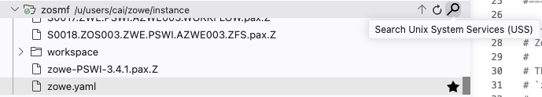

- Find java.home. Write down its value:
java.home

- SSH Check which Java version that path points to. Replace the path with your value:
<java.home value>/bin/java -version
- In the migration guide, find which Java version Zowe v3 requires. Compare it with what you found.
- IDE Change java.home to the Java installation that meets the requirement (see Reference Material) and save the file. Zowe Explorer uploads the file to z/OS when you save.
- SSH Verify the new path the same way. The output must show the required version.

Also look at node.home in the same file and compare it with the Node.js versions in the guide.
Checkpoint: java -version run from the new java.home shows the Java version required by Zowe v3: IBM Semeru Runtime Certified Edition for z/OS 17.0.10.0

Step 2: Syntax Validation and Schema Updates
Zowe v3 removed several settings that were standard in v2 and changed the allowed values of others. The "Configuration changes" section of the migration guide describes them.
Warning: YAML depends on indentation. Use spaces, never tabs, and do not change the indentation of lines you are not editing.

- SSH Make a backup before you edit anything:
cd /u/users/cai/zowe/instance
cp zowe.yaml zowe.yaml.bak
- IDE Open zowe.yaml and make the four changes below. Read each path left to right as nested YAML sections.
Where in zowe.yaml | Change
zowe > useConfigmgr | Remove the property. It is no longer supported.
components > gateway > server | Remove the entire server section as internal. Does not exist anymore and property server can’t exist without any offsprings
components > gateway > apiml > security > auth > provider | Set the value to saf, so we have less dependencies and communicate directly to SAF
components > gateway > apiml > security > auth > zosmf | Remove or comment out the entire zosmf section as we’ve switched to saf
components > gateway > apiml > security > authorization > provider | Set the value to native.

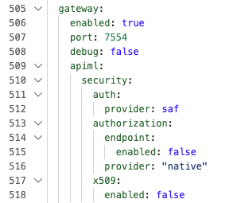

- IDE Save the file.

- SSH Run the pre-flight validation. Zowe checks the configuration without starting:
cd /u/users/cai/zowe/runtime/bin
./zwe config validate -c /u/users/cai/zowe/instance/zowe.yaml
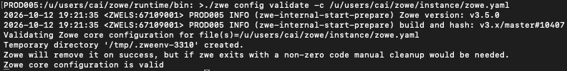

- SSH Run Zowe's dependency check, which verifies the Java and Node.js versions:
./zwe validate dependencies -c /u/users/cai/zowe/instance/zowe.yaml
Expected result:
Note: The Node version check validation may fail with return code: 127, user we are checking it with, do not have permissions on this system for node, but Zowe user does.
Any other error is unexpected though.

Checkpoint: The commands report that the configuration is valid.
If it reports errors, read them: they point to the property that is wrong. Fix it and run the command again.

Step 3: Network Integrity
A valid configuration file is not enough. Zowe also needs its network ports to be available, and you can check that before starting it.
- SSH Check whether the ports needed by the enabled Zowe components are free:
./zwe validate port bind -c /u/users/cai/zowe/instance/zowe.yaml -vv
Expected result: the command reports that port 7558 is not available.
ERROR: 2026-10-07 13:56:23 <ZWELS:33554523> PROD005 ERROR (zwe-validate-port-available) ZWEL0357E: zaas Port 7558 not available for jobname ZWE1AZ or command failed.
- IDE In zowe.yaml, search for 7558. Is it in the file?
- Find out where port 7558 comes from. Search the migration guide for zaas.
Explanation: ZAAS (Zowe Authentication and Authorization Service) is a new component in v3. It is enabled by default and uses port 7558 even when zowe.yaml does not mention it. Your configuration comes from v2, which did not have this component, so the file says nothing about it.

- SSH Find out who is using port 7558:
onetstat -o | grep 7558
Expected result: the port is reserved for another job name
- IDE Free the port: in Zowe Explorer, issue these two MVS commands, one at a time.
V TCPIP,,SYNTAXCHECK,PROD005.TCPIP.OBEY(DELPORT)
V TCPIP,,OBEYFILE,DSN=PROD005.TCPIP.OBEY(DELPORT)
The first command checks the syntax of a prepared TCP/IP profile member that releases the port, the second applies it. TCP/IP is not restarted.
- WEB There is one more page could be found in the Zowe docs below the migration guide: Upgrading to single-service API ML deployment. The single-service deployment reduces the Zowe footprint by running the Gateway, Discovery Service, API Catalog, Caching Service, and ZAAS within a single address space, which also removes excessive network load and lowers ports count
- IDE In zowe.yaml, find the components section and add new apiml component

- SSH Run the netstat command again, then zwe validate port bind again, note that less ports are required now.

Checkpoint: Port 7558 is no longer reserved to the other job, and zwe validate port bind completes without errors.

Step 4: Security Verification
Security is the other common startup blocker. The core requirements are close to v2, but it is useful to verify that the Zowe user ZWESVUSR has all the permissions it needs.
- WEB Open the z/OSMF tile and log in.
- WEB Open the Security Configuration Assistant.
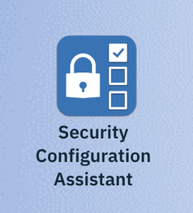
- WEB Switch to the Imported Products tab.
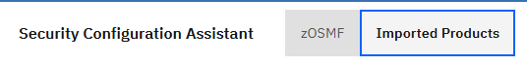
You should be able to see the Zowe Configuration - Server tile
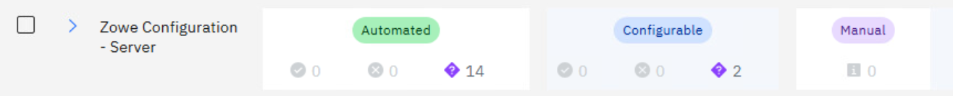
If you do not see the Zowe Configuration - Server tile in the Imported products
Note: If you do not see the Zowe Configuration - Server tile in the Imported products then click Import button to import the Zowe security descriptors located in the Zowe runtime directory: /u/users/cai/zowe/runtime/files/sca

- WEB Enter ZWESVUSR in the "Validate for ID" field and run a full validation.



Checkpoint: The validation shows that all checks passed.

Step 5: Certificate Chain
Zowe uses TLS for the communication between its components, and an incomplete certificate chain is a common cause of failures. The Certificate Setup Assistant for Z (CSAz) in z/OSMF shows key rings and certificates and lets you fix them.
- IDE In zowe.yaml, find the certificate configuration. Write down the key ring and the certificate alias:
Key ring and alias

- WEB In z/OSMF, open the Certificate Setup Assistant for Z.
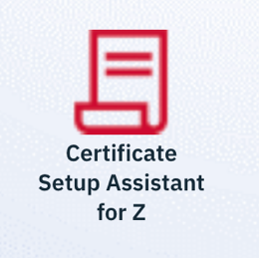
- WEB Go to the Key Rings section. In the "Displayed Scope", add ZWESVUSR and remove your own user ID, then click Apply.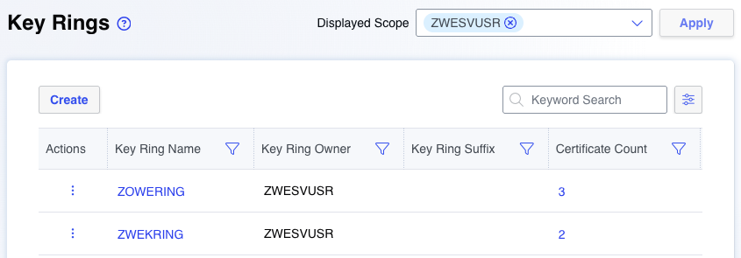

- WEB Open the details of the ZWEKRING key ring.
Certificates connected to the key ring:

- WEB Go to the Certificates section. In the "Displayed Scope", add SITE and CERTAUTH, then click Apply.

- WEB Open the ROOTSTAR certificate and check its trust status, validity and chain. The chain contains three certificates, but the key ring holds only two. The intermediate CA is missing.
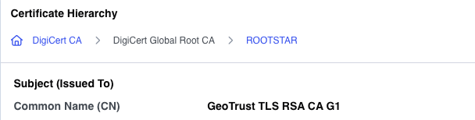
- WEB Find the intermediate certificate in the list: DigiCert Global Root CA
- WEB Open its action menu (three dots) and select Connect Certificate to Key Ring. Select ZWEKRING from the list, or type it, set Usage Type to CERTAUTH and connect.
- WEB Return to the Key Rings section, open ZWEKRING again and check that the chain is complete.
You can also connect same certificate from this page by name DIGIROOT
- SSH Run Zowe's certificate check:
./zwe validate certificate -c /u/users/cai/zowe/instance/zowe.yaml -vv
Checkpoint: The certificate check completes without errors.

Step 6: Final Execution
The environment is verified: prerequisites met, configuration valid, ports free, security audited and the certificate chain complete. Time for the one allowed restart.
- IDE In Zowe Explorer, right click on zosmf profile and Issue Console Command 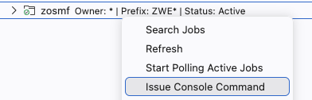
- IDE Type the command S ZWESLSTC below:
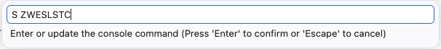
- IDE Refresh the JOBS list, find the new ZWESLSTC job and open its spool files. Follow the messages while Zowe starts. You may right-click on the SYSPRINT file and select Start Polling option for the spool content to be pulled from the mainframe every 5 seconds.
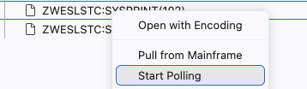
Startup takes about 10 minutes on this sandbox.
Messages to look for in the job output:
Message | Meaning
ZWEAM000I  ZWEAM001I | An API Mediation Layer component has started. One message ZWEAM000I per API ML address space. ZWEAM000I is the final message for API ML.
ZWES1013I | The ZSS server has started.
ZWES1014I | ZIS status is Ok.
ZWES1601I | The ZSS registered with the API Gateway.

Note: No single message says that Zowe is ready. You verify each component, and the next step does exactly that.
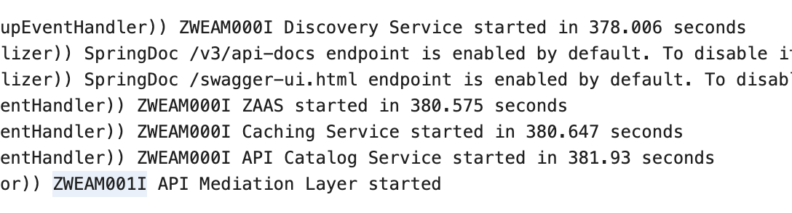

Step 7: Verify the Result
- WEB Open a new tab in the browser and use same mainframe host name and port 7554 to open the API ML home page.
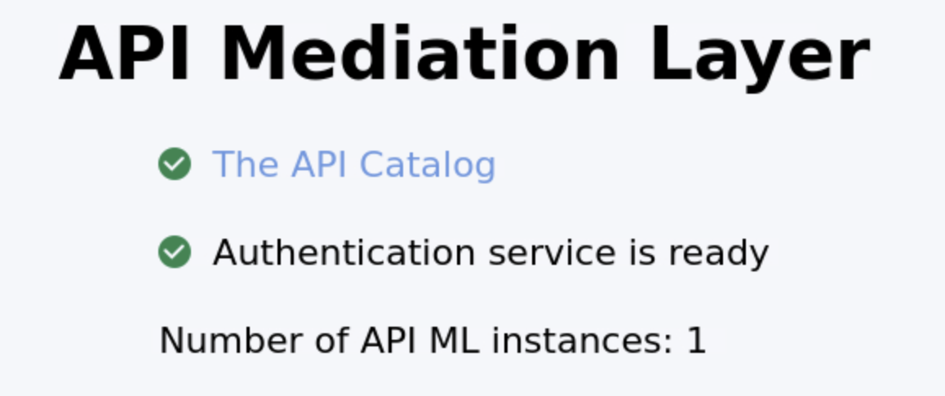
- WEB Click on the API Catalog tile and log in. Check that the services are listed and healthy.

Checkpoint: Zowe is up after a single restart, and you never had to guess what was wrong.

What You Used
Task | Tool | Where
Read logs, edit files, start Zowe | Zowe Explorer | IDE
Check requirements and configuration changes | Zowe v3 migration guide | WEB
Validate configuration, ports, dependencies and certificates | zwe command | SSH
Audit the Zowe user's permissions | z/OSMF Security Configuration Assistant | WEB
Inspect and repair the certificate chain | z/OSMF Certificate Setup Assistant for Z | WEB

Reference Material
Item | Value
Zowe started task | ZWESLSTC
Zowe configuration file location | /u/users/cai/zowe/instance
Zowe runtime directory | /u/users/cai/zowe/runtime
Directory with the zwe command | /u/users/cai/zowe/runtime/bin
Java 17 home path | /sys/java64bt/v17r0m0/usr/lpp/java/current_64
Node.js home path | /usr/lpp/IBM/cnj/IBM/node-latest-os390-s390x
Zowe security descriptors for SCA | /u/users/cai/zowe/runtime/files/sca
Zowe user | ZWESVUSR
Zowe key ring | safkeyring://ZWESVUSR/ZWEKRING
Zowe certificate alias | ROOTSTAR
Default port: API Gateway | 7554
Default port: ZAAS | 7558
Your personal details | README file in your IDE

